Output:

Wireshark Capturing

Start Wireshark from terminal



Non-Promiscuous Mode

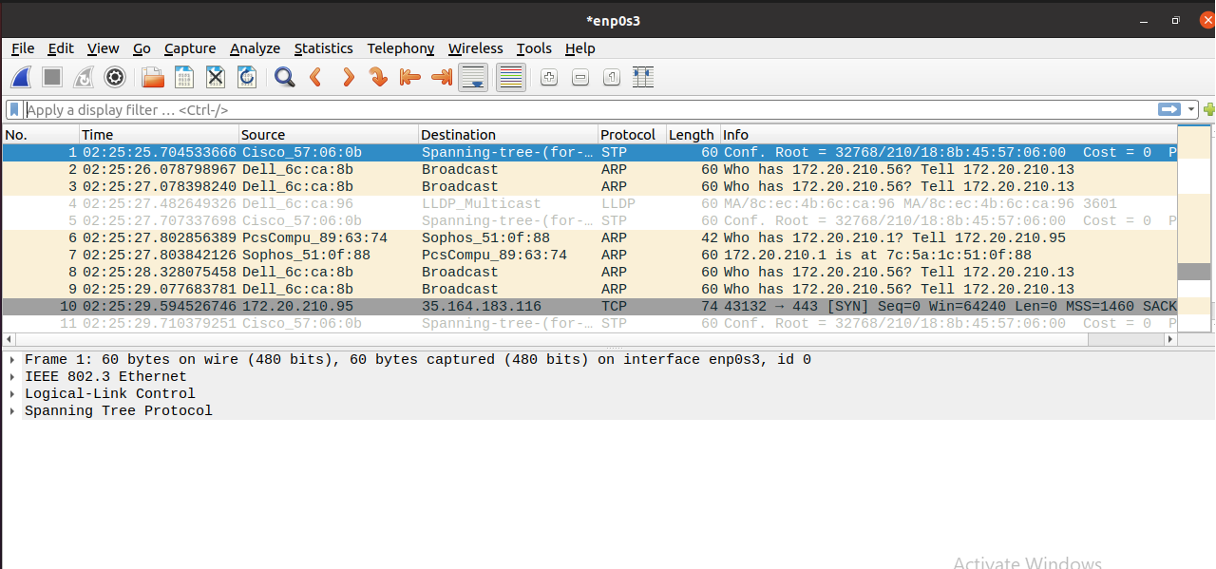

Start Capturing

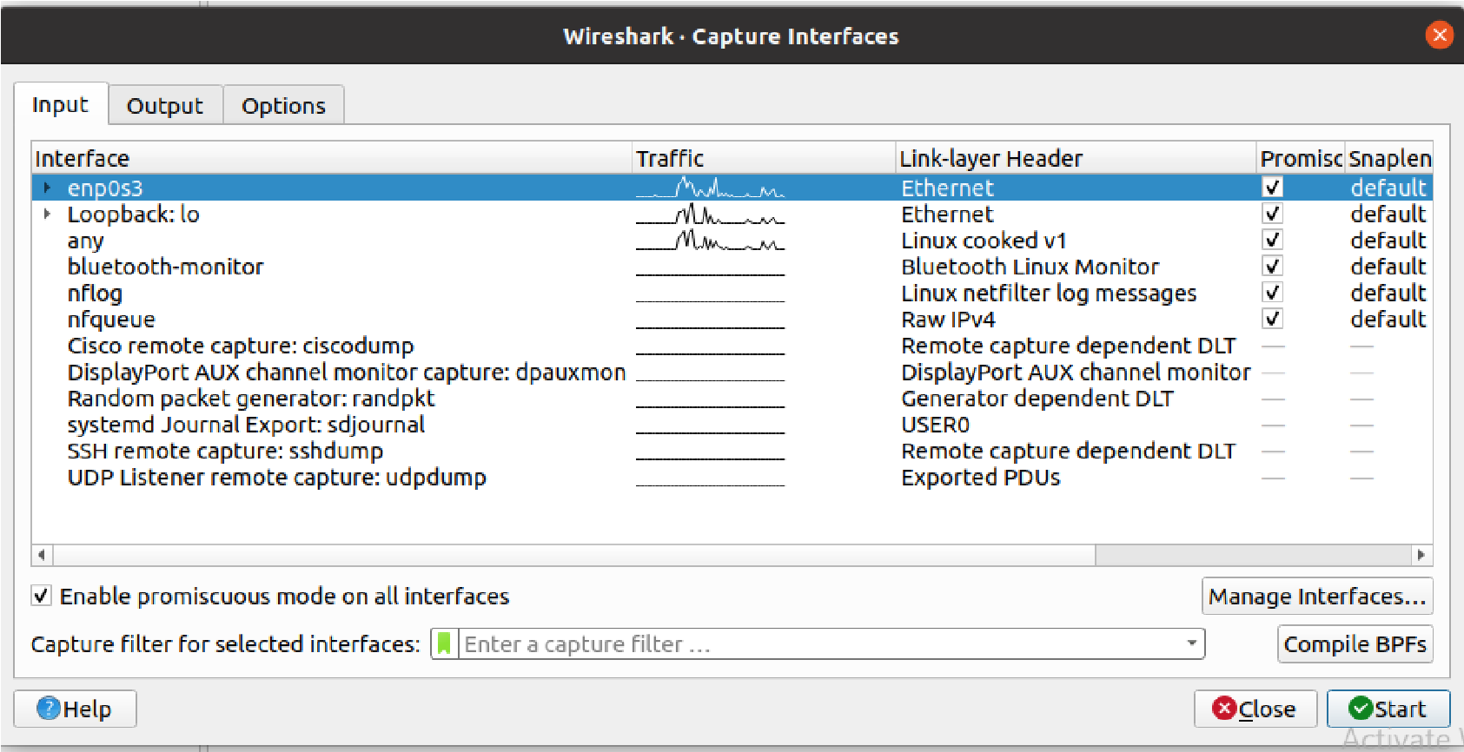

For HTTP

Go to the Moodle IP Address and login using username and password

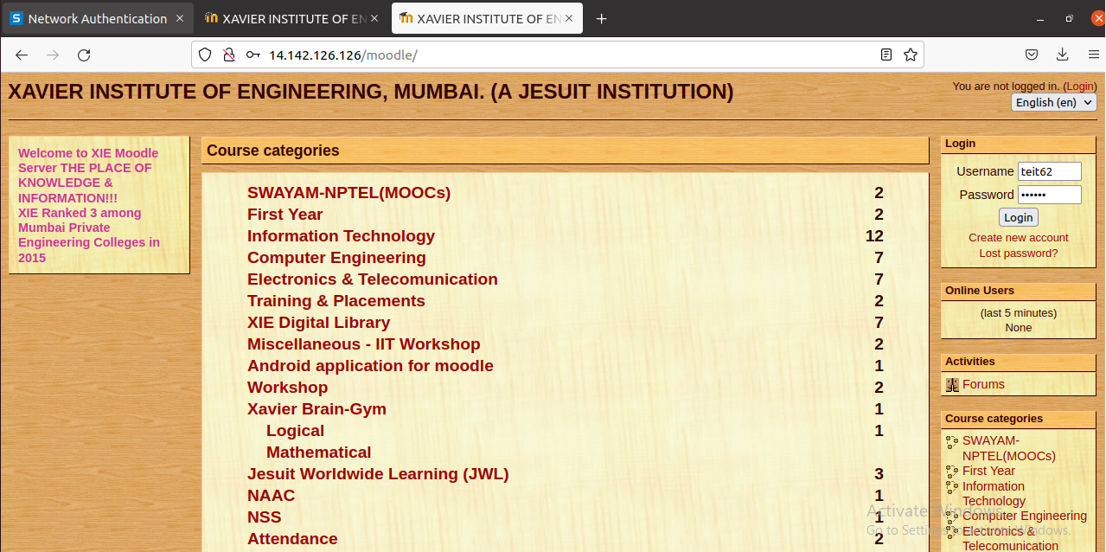

Now stop the capture and select the http packet with POST method

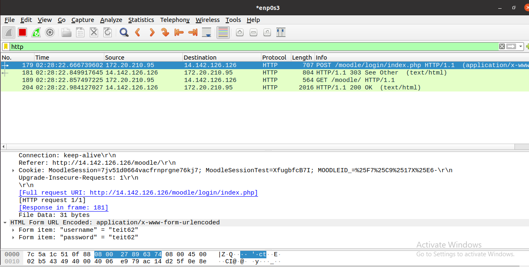

For HTTPS

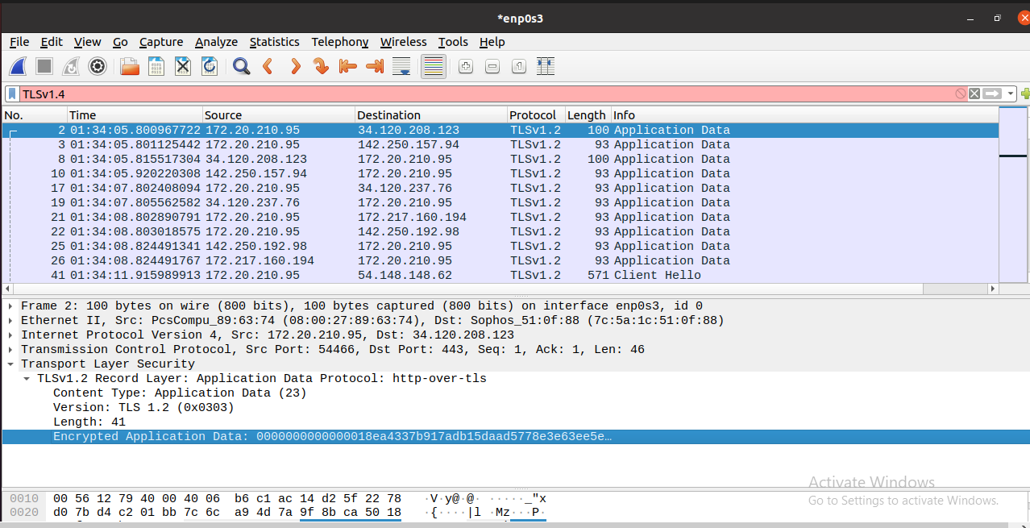

For SSH

